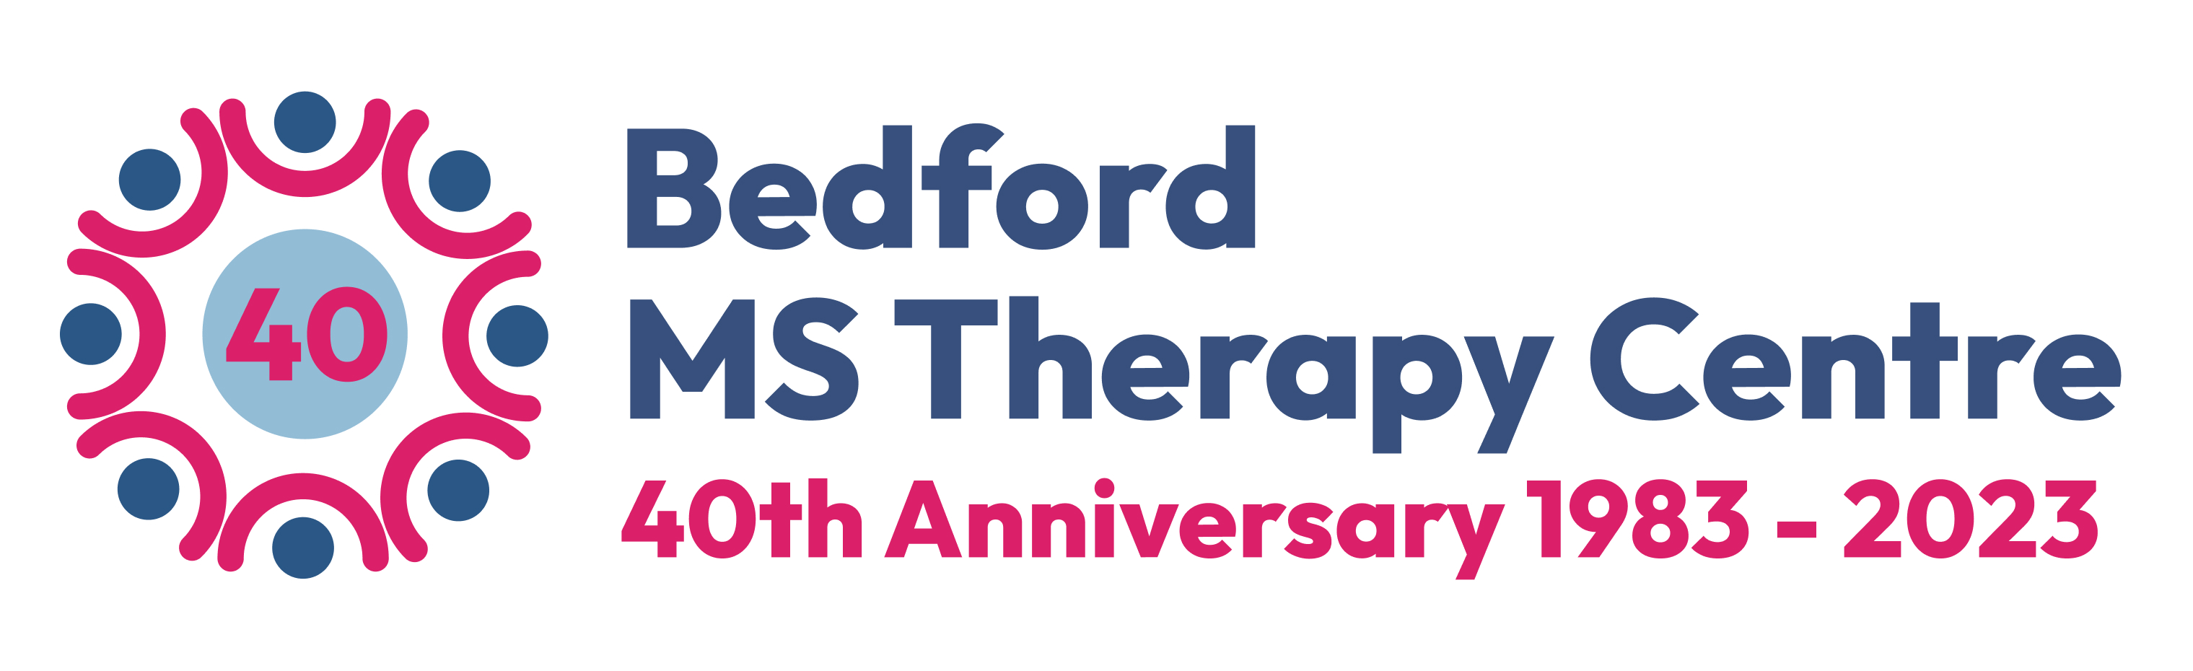
Donations

Name:____________________________

Date ______________________________

Amount of donation: ______________

Cash/BACS/credit or debit card
Please say which

To donate by BACS: Please credit HSBC Bank sort code: 40-10-02 Account Number 72374463

Do you pay tax? If so, we can claim gift Aid on your donation.
Please fill in your details below.

Gift Aid Declaration
I am a UK taxpayer and understand that if I pay less Income Tax and/or Capital Gains Tax in the current tax year than the amount of Gift Aid claimed on all my donations it is my responsibility to pay any difference.
I wish to Gift Aid my donation/any future donations to the Beds and Northants MS Therapy Centre
Please let us know if you cease to pay tax equal to your donation, if you change your name or address, or wish to cancel this declaration.

House number or name
Signature
Postcode

Set up a regular donation

To the manager:

Bank Name ____________________________________ Name on Account _______________________________

Address _______________________________________. Sort Code ______________________________________

Postcode ______________________________________ Account number ________________________________

Please debit my account monthly by the sum of £40/£50/£60 or other

Please credit HSBC Bank sort code: 40-10-02 Account Number 72374463

Commencement date until further notice

Signed
Dated

